**French Learning Pack**

**for**

**Emmy and the Iris:**

**A Fanciful French Twist on *The Secret Garden***

**This pack includes:**

**Vocabulary Match**

**Who Said It?**

**Crossword Puzzle**

**Cultural Lesson**

**Answer Keys**

**Coloring Page**

**Certificate of Completion**

**Vocabulary Match**

***Draw a line from the words on the left to match the words on the right. How many have you learned?***

|  |  |
| --- | --- |
| 1. Pharmacie | hair |
| 1. Boulangerie | shoes |
| 1. Crêpes | cabbage (also used to mean “cute”) |
|  |  |
| 1. Un avion | salad or lettuce |
| 1. Fraise | candy |
| 1. Viens ! | cucumber |
| 1. Frigo | and look… |
| 1. Vite | bakery |
| 1. Baguette | quality |
| 1. Soucis | strawberry |
| 1. Cheveux | Come here ! |
|  |  |
| 1. le four et les plaques | fast, quick |
| 1. Camembert | microwave oven |
|  | a very thin pancake |
| 1. Et regarde… |  |
| 1. Lamère | the oven and stove |
| 1. Châteaux | castles |
| 1. Chaussures | worries or marigolds |
| 1. Qualité | refrigerator |
| 1. Bonbons | The name of the castle. It looks like “la mère”, which means “the mother”. |
| 1. Chou 2. Salade | a type of soft cheese  French bread |
| 1. Micro-onde | airplane |
| 1. Concombre | pharmacy, drugstore |
|  |

|  |
| --- |
|  |

**Who Said It?**

***Can you remember which characters used these words in the book? Write the name of the character in the first column and the translation of the word in English in the second column. The first one has been done for you.***

|  |  |  |
| --- | --- | --- |
| Un avion | *Raymond* | *Airplane* |
| Viens! Au milieu, avec les autres. |  |  |
| qualité |  |  |
| bonbons |  |  |
| Et regarde… le four et les plaques |  |  |
| Salade |  |  |
| Les soucis |  |  |

**Food and Flowers Crossword Puzzle**

|  |  |  |  |  |  |  |  |  |  |  |  |  |  |  |  |  |  |  |  |  |  |  |  |  |  |  |  |  |  |  |  |  |  |  |
| --- | --- | --- | --- | --- | --- | --- | --- | --- | --- | --- | --- | --- | --- | --- | --- | --- | --- | --- | --- | --- | --- | --- | --- | --- | --- | --- | --- | --- | --- | --- | --- | --- | --- | --- |
| |  |  | | --- | --- | | **Across** | | | **4.** | something sweet | | **6.** | what you use to heat up cold food | | **9.** | a green plant you can eat | | **11.** | French bread | | **12.** | what you use to bake bread | | **13.** | a very thin pancake | |  | |  |  | | --- | --- | | **Down** | | | **1.** | the surface on which you cook | | **2.** | worries or marigolds | | **3.** | a long green vegetable you can eat | | **5.** | a place where you can buy bread | | **7.** | a small red fruit | | **8.** | a word that can mean "cute" | | **10.** | a type of soft cheese | | **12.** | a cold place | |

**Cultural Lesson**

***You may have noticed that Emmy encounters cultural differences between France and the U.S. In the first column is an extract from the book that represents a cultural difference. Do you know what that difference is? Write your explanation in the second column. The first one has been done for you. If you don’t know, you can research it or use the answer key!***

|  |  |
| --- | --- |
| *“The car is jumping around everywhere…* | *As Laney explains, the car is a stick-shift car. Many cars in France are stick-shift and not automatic like in the U.S.* |
| … and the signs are strange,” she grumbled. |  |
| “Yes. But Jérémie speaks it better than I do. He was born speaking it.” |  |
| “Only adults can drink it [wine]  because children’s tongues will not support ze taste, and it makes you sleepy. But my dad says zat when I am 18, I will be an adult…” |  |

**Vocabulary Match Answers**

***Draw a line from the words on the left to match the words on the right. How many have you learned?***

|  |  |
| --- | --- |
| 1. Pharmacie | hair |
| 1. Boulangerie | shoes |
| 1. Crêpes | cabbage (also used to mean “cute”) |
|  |  |
| 1. Un avion | salad or lettuce |
| 1. Fraise | candy |
| 1. Viens ! | cucumber |
| 1. Frigo | and look… |
| 1. Vite | bakery |
| 1. Baguette | quality |
| 1. Soucis | strawberry |
| 1. Cheveux | Come here ! |
|  |  |
| 1. le four et les plaques | fast, quick |
| 1. Camembert | microwave oven |
|  | very thin pancakes |
| 1. Et regarde… |  |
| 1. Lamère | the oven and stove |
| 1. Châteaux | castles |
| 1. Chaussures | worries or marigolds |
| 1. Qualité | refrigerator |
| 1. Bonbons | The name of the castle. It looks like “la mère”, which means “the mother”. |
| 1. Chou 2. Salade | a type of soft cheese  French bread |
| 1. Micro-onde | airplane |
| 1. Concombre | pharmacy, drugstore |

**Who Said It? ANSWERS**

***Can you remember which characters used these words in the book? Write the name of the character in the first column and the translation of the word in English in the second column. The first one has been done for you.***

|  |  |  |
| --- | --- | --- |
| Un avion | *Raymond* | *Airplane* |
| Viens ! Au milieu, avec les autres. | Madame Jolie | Come here! In the middle, with the others. |
| qualité | Michaël | quality |
| bonbons | Michaël | candy |
| Et regarde… le four et les plaques ! | Sarah | And look… the oven and the stove! |
| Salade | Michaël | Salade or lettuce |
| Les soucis | Michaël and Emmy | Worries or marigolds |

**Cultural Lesson ANSWER KEY**

***You may have noticed that Emmy encounters cultural differences between France and the U.S. In the first column is an extract from the book that represents a cultural difference. Do you know what that difference is? Write your explanation in the second column. The first one has been done for you. If you don’t know, you can use the answer key!***

|  |  |
| --- | --- |
| *“The car is jumping around everywhere…* | *As Laney explains, the car is a stick-shift car. Many cars in France are stick-shift and not automatic like in the U.S., although automatic cars are becoming much more common.* |
| … and the signs are strange,” she grumbled. | *The signs are in French. The colors of the signs indicating what type of highway or road it is are different.* |
| “Yes. But Jérémie speaks it better than I do. He was born speaking it.” | *They speak French in France.* |
| “Only adults can drink it [wine]  because children’s tongues will not support ze taste, and it makes you sleepy. But my dad says zat when I am 18, I will be an adult…” | *In France, adults can drink wine at 18 years of age. In the U.S., the minimum age is 21.* |

**Food and Flowers Crossword Puzzle ANSWERS**

|  |  |  |  |  |  |  |  |  |  |  |  |  |  |  |  |  |  |  |  |  |  |  |  |  |  |  |  |  |  |  |  |  |  |  |
| --- | --- | --- | --- | --- | --- | --- | --- | --- | --- | --- | --- | --- | --- | --- | --- | --- | --- | --- | --- | --- | --- | --- | --- | --- | --- | --- | --- | --- | --- | --- | --- | --- | --- | --- |
| |  |  | | --- | --- | | **Across** | | | **4.** | something sweet | | **6.** | what you use to heat up cold food | | **9.** | a green plant you can eat | | **11.** | French bread | | **12.** | what you use to bake bread | | **13.** | a very thin pancake | |  | |  |  | | --- | --- | | **Down** | | | **1.** | the surface on which you cook | | **2.** | worries or marigolds | | **3.** | a long green vegetable you can eat | | **5.** | a place where you can buy bread | | **7.** | a small red fruit | | **8.** | a word that can mean "cute" | | **10.** | a type of soft cheese | | **12.** | a cold place | |

**Coloring Page – Fleur de lys (yellow iris)**

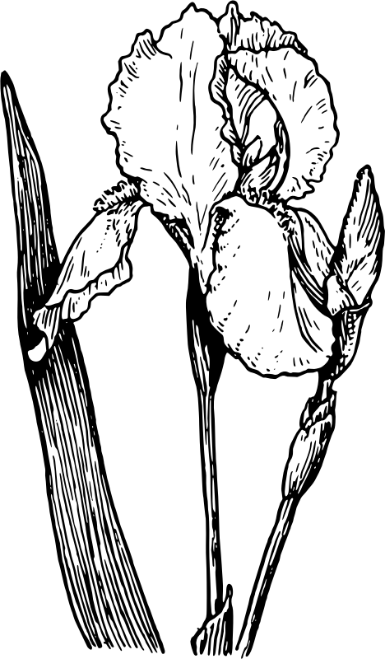

**Coloring Page – *Fleur de lys* symbol**

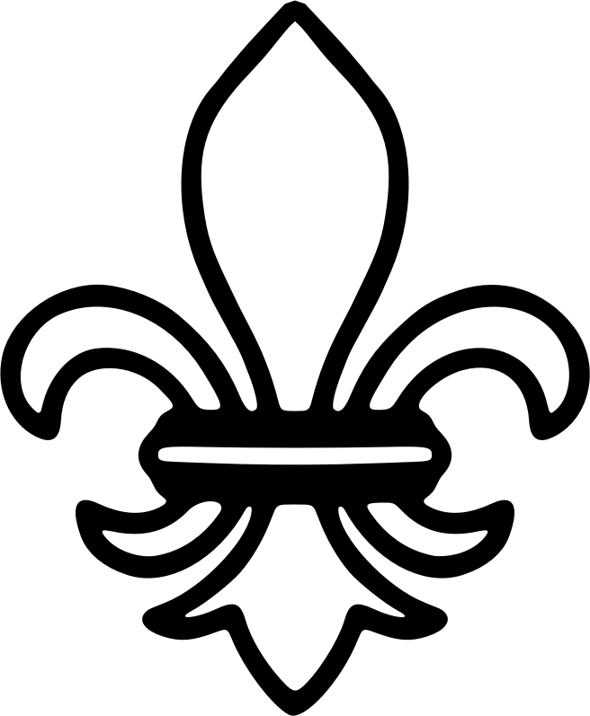

**CERTIFICATE**

**OF**

**COMPLETION**

**Approved**

This diploma hereby certifies that

has completed the French Learner Pack for

Emmy and the Iris:

A Fanciful French Twist on *The Secret Garden.*

Félicitations!

Signature

Date